**IFB299 Personal Portfolio 1**

**Name: Virginia IP n8810532**

**Due Date 22/10/2015**

This document states five significant and distinctly different artefacts from the current release that I have contributed to the group. It includes a brief description of each artefact describing its contribution in the context of the project.

As an Information System and business student, we focused more on non-technical tasks in the group. Here are the five artefacts:

**Artefact 1 – Prototype Design** 2

**Artefact 2 – Peer Review 2** 2

**Artefact 3 – Test Case v3.0** 2

**Artefact 4 – Automatic Testing** 2

**Artefact 5 – Test Cases** 2

**Artefact 6 – Others** 2

# **Artefact 1 – Prototype Design**

I have created interactive “hand drawn sketchy look” prototype for the property management system. It is helpful for CS students to develop the system on visual studio based on this design. I strive to create useful and usable products according to client demand. Please open the **YouTube shortcut** for a demo.

# **Artefact 2 – Peer Review 2**

The peer review is an opportunity for the client team to provide constructive feedback to their developer team. In week 11 we listened to a presentation by the development team, I was responsible to collect my members’ opinion and write the part relating to “Professionalism of the Presentation”. The letter is formal document to the development team. As a result, I avoided using informal language like contractions and slangs.

Please read **Peer Review 2.docx** for details.

# **Artefact 3 – Test Case v3.0**

I wrote test case for functional testing in order to verify whether we have built a correctly working product. This document can help the team to ensure the system meet the business requirements and acceptance criteria. I listed some possible scenarios to ensure the system accept correct data and reject incorrect inputs. The system is incomplete at this stage. Some of the functions are not ready for me to do testing. But I still think that have a test case document will smooth the testing procedure in the future.

Compare to test case in the previous release, the number of test case is more than doubled. It covers a more comprehensive testing. Tests failed in the previous release are redone.

Please read **Test Case v3.0.docx** for details.

# **Artefact 4 – Automatic Testing**

Selenium is used to our Property Management website. It greatly saves our time use in testing especially for some repeated and similar items. The automation ensures that each test is rigorously executed every time. I can input command to ask the software to save screenshots automatically at different testing points. By verifying these screenshots I can ensure the test run correctly. I spent quite a fair bit of time to compare different types of automatic testing tools including eggplant, routinebot, sikuli slides, renorex, and many chrome extensions. All of the listed software is not very compatible with our webpage which is created on FileMaker. At last, I chose selenium and made a slight adjustment in the script in order to let the script to run. Sometimes the script cannot run properly, the trick is you have to close all the tab before running the script.

Please read **Automated Testing Summary.docx** for details.

# **Artefact 5 – Interview with potential users**

The interview has the aim of collecting insights on opinions about experience using the property management system. Interviewing people in context allows me to question in real time when they are using the system.

Please read **Interview Report.docx** for details.

# **Artefact 6 – Others**

* Created dump data in database for the system to run and allow testing to be executed.
* Created user interface in visual studio for inspection record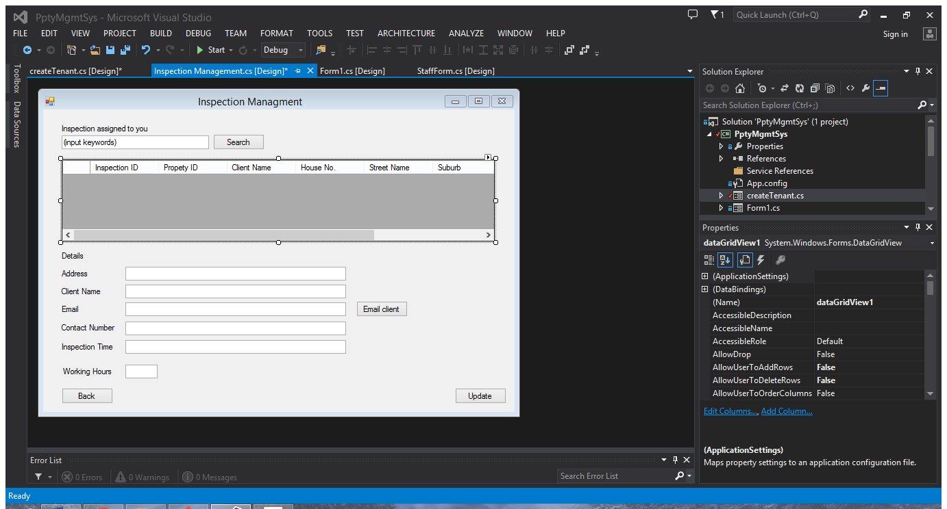
* Our group JIRA was not very well maintained. I took the initiative to add subtasks after we have a new sprint plan in place. These valuable information provides team members and client team a reminder of what is happening and thus helps tracking progress and aiding our planning.